Release 1 - Issues September 5, 2012

- Test Update feature once the tool is deployed on our internal Panasonic website.
- Change “netcaredata” to “Panasonic” site…
- Replace “Report an Issue” with email address: Isabel.lachin!
- Look into changing the certificate name from “Panasonic Corporation…” to “Panasonic Software Solutions”
- (NO ISSUE: Install automatically installs the certificate!)
Automate Certificate Installation so that the certificate gets installed automatically on users machine.
Currently during Install, a “Security Warning” message is triggered with Publisher as “Panasonic Corporation of North America”. In order to bypass this message for future installations the customers has to install the certificate on their machine and into their store.

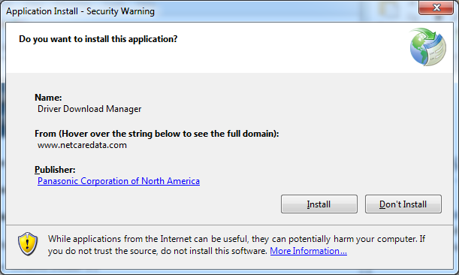

How to Install the Certificate
- Click on “Panasonic Corporation of North America” link.
- Click on “Install Certificate…” . Starting Wizard -> Click Next.

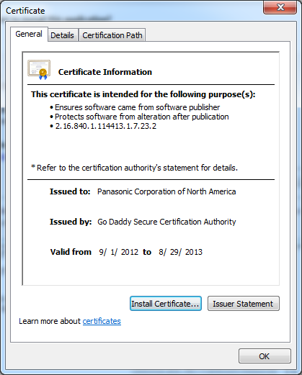

- Select Radio button: “Place all certificates in the following store”.
- Select “Certificate store:” to be “Trusted Publishers”.
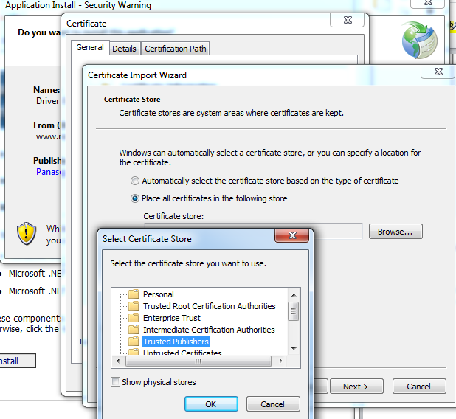

- Finish the Wizard and continue with Install.
For future installations - as long as the certificate still resides on users machine - the “Security Warning” message will be hidden.

- There are issues when sorting, moving from one driver to another, the driver list and the actual database don’t match.

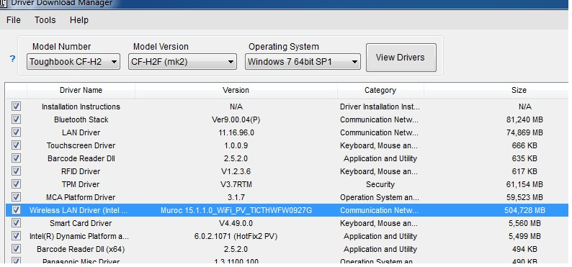

- Some progress bar issues customers are seeing.

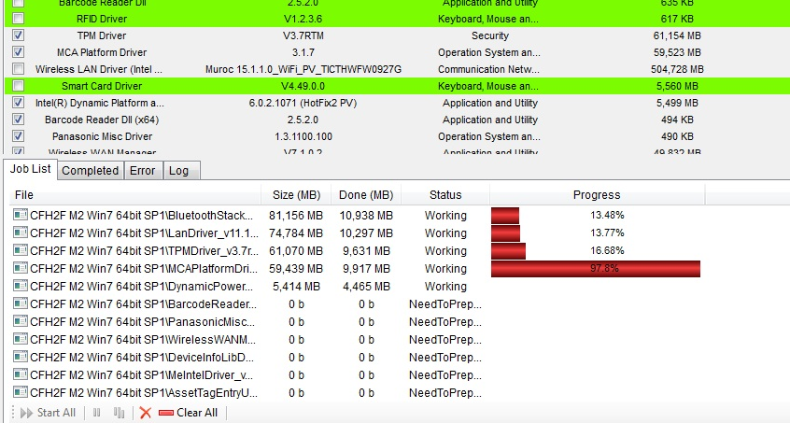

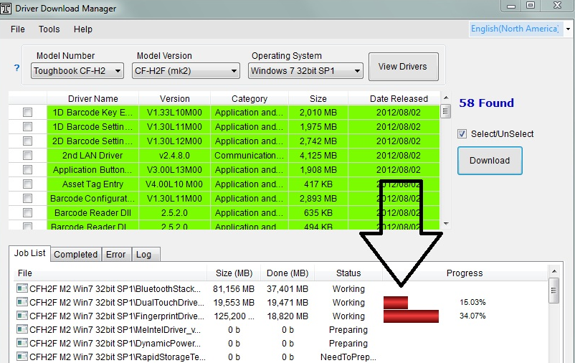

- Size of the files in the view window does not have the correct sizes posted.
(e.i. 2nd Lan is 4,105MB = 4.1GB).

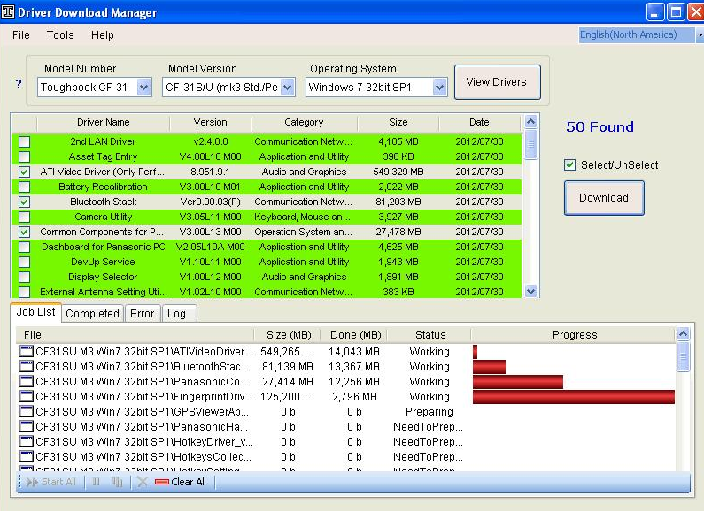

(Julian Eliston)
1. When I queried all the drivers the application does not show me a total size or estimation of time to download what I have selected.

I can understand not having estimated time. It is not necessary. I think the total size of packages being downloaded is absolutely necessary or else how will the user know how much space is needed on the HDD or flash drive. Every download from another source tells the user the size of the file they are about to download and while there are downloading it will show overall progress.

We are not giving the user any indication of how long the download will take. In order for the user to know to know what has completed, the user must check the completed tab or the folder that the download creates.

- CF-19 driver issue. This issue came from customers (Nextera Energy – Michael Perrone) and they saw the app hang few times.

CF-19 Issue
